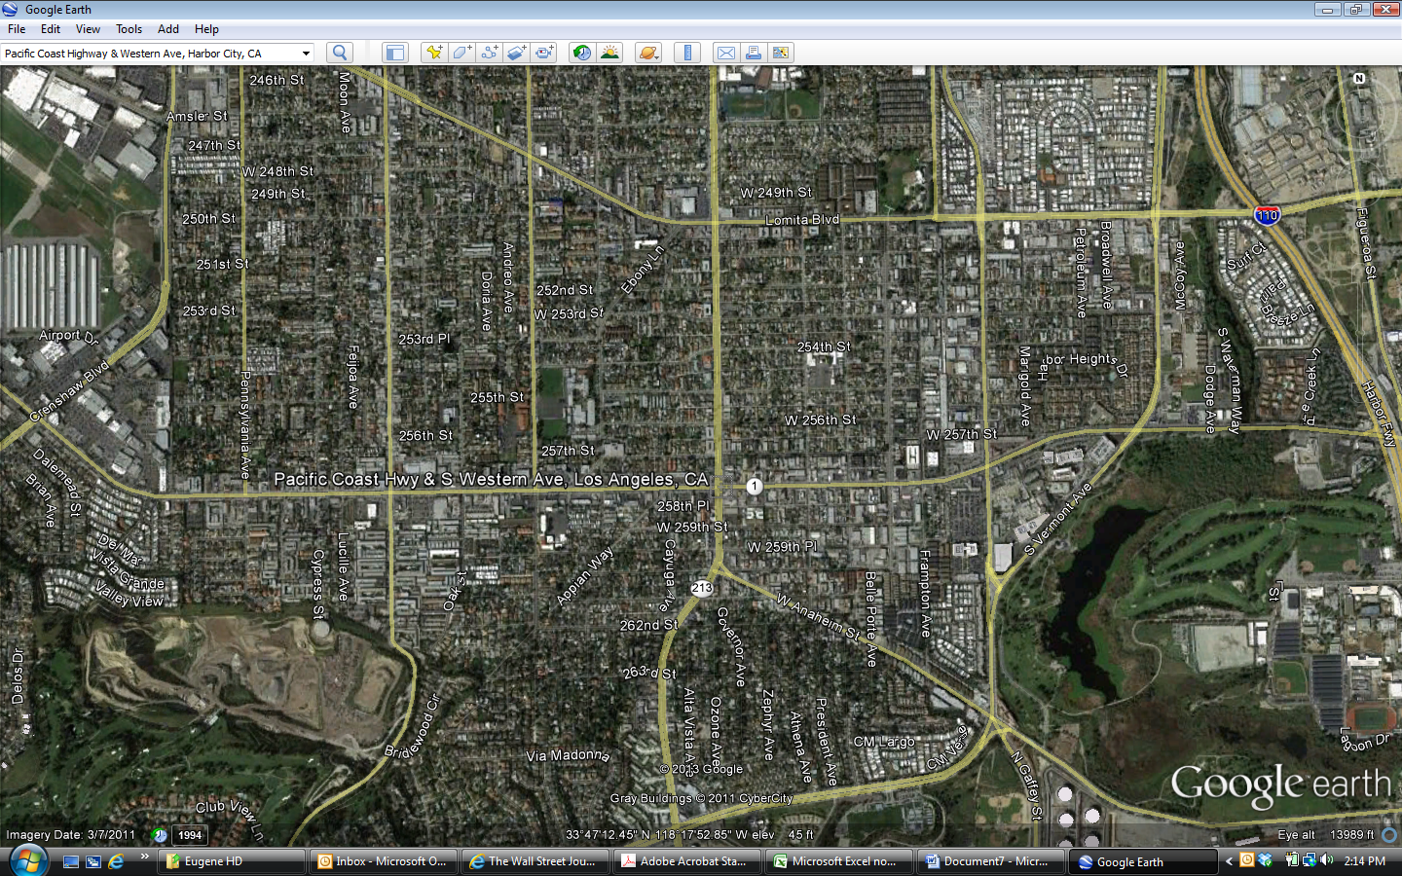

***Pacific Plaza***

Rolling Hills Plaza

Torrance Town Center

Kaiser Permanente South Bay Medical Center